* + 1. **CloudFront Hands On:**

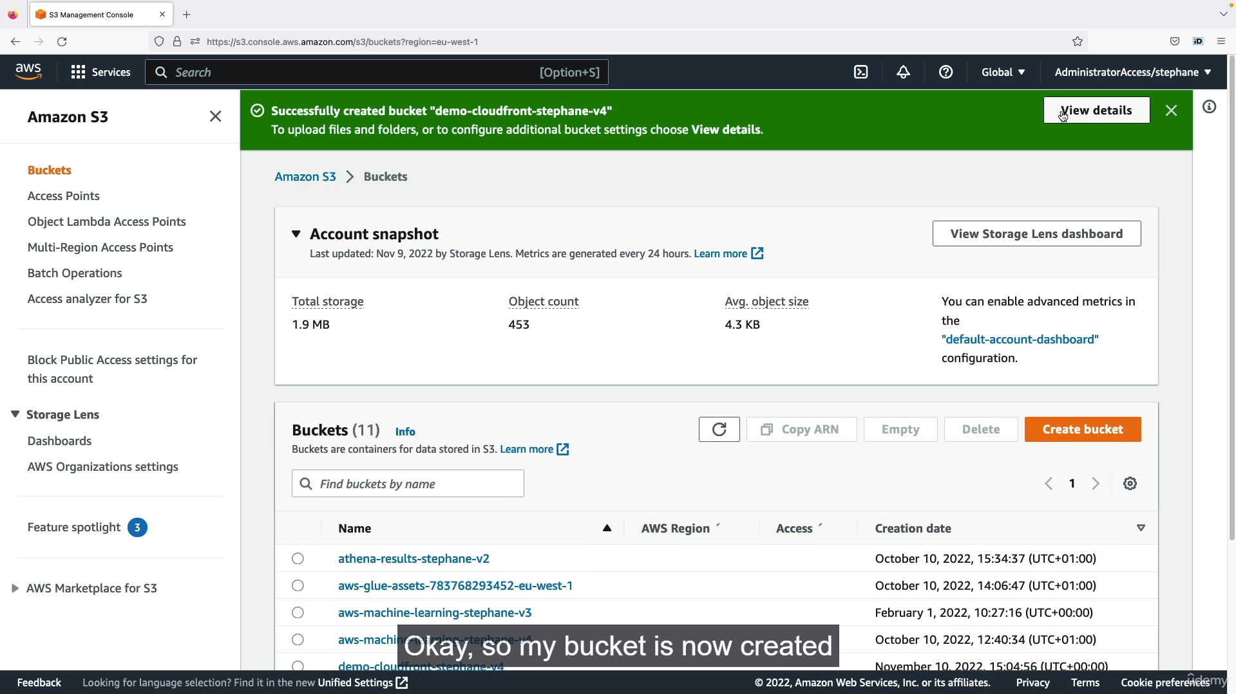

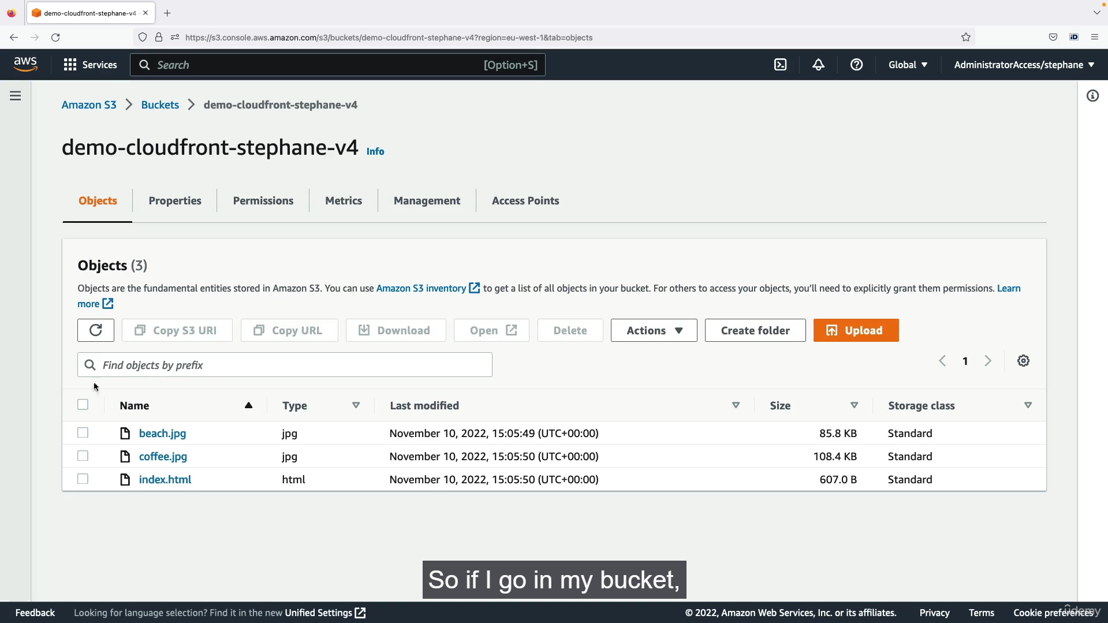



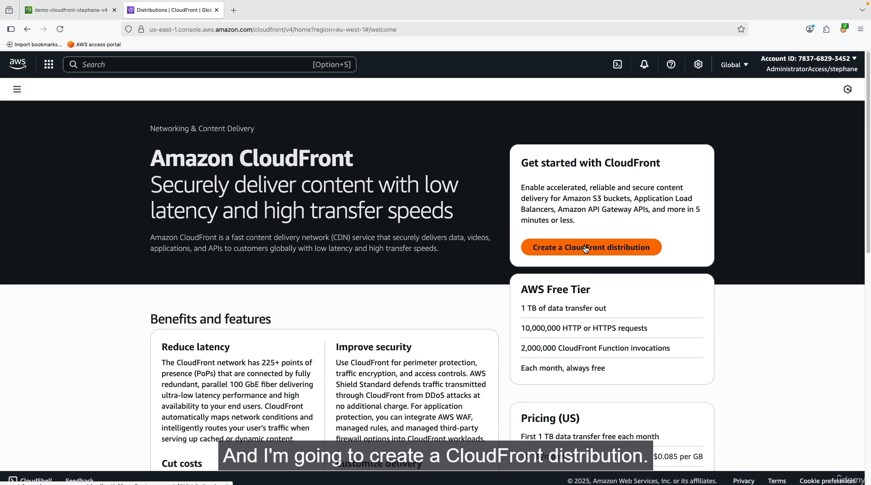

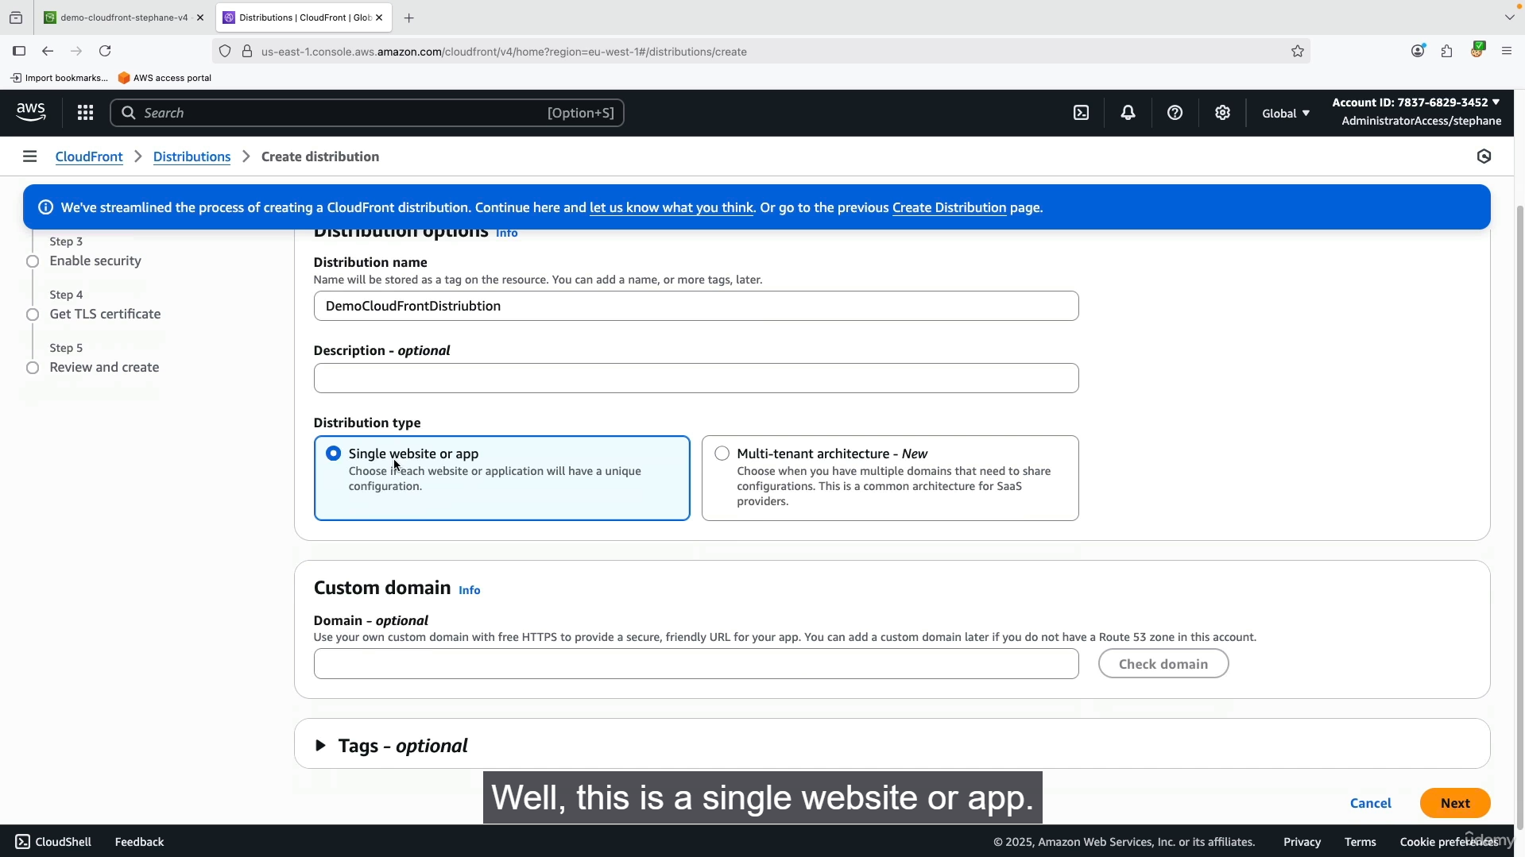

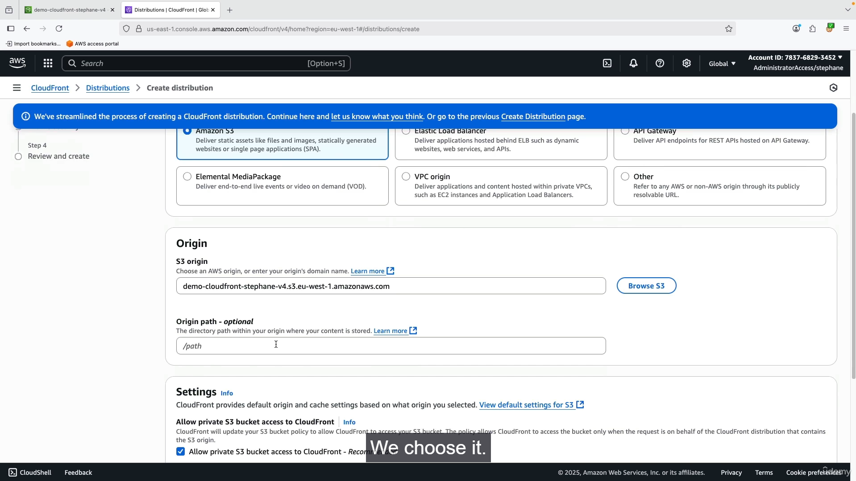

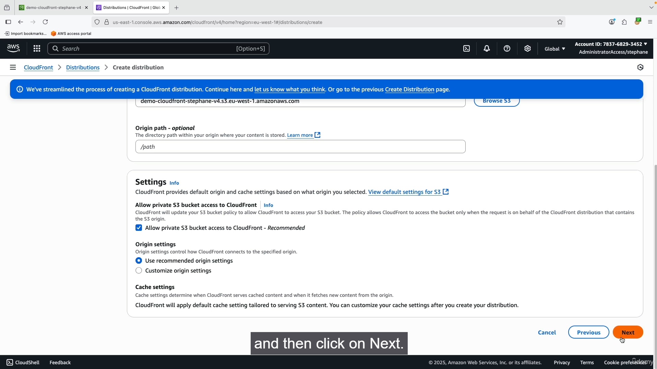

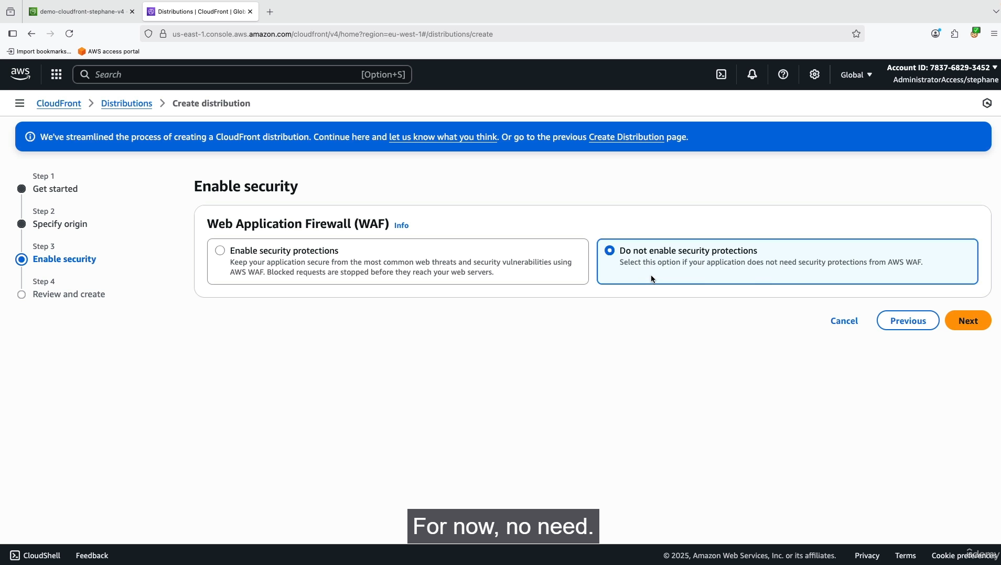

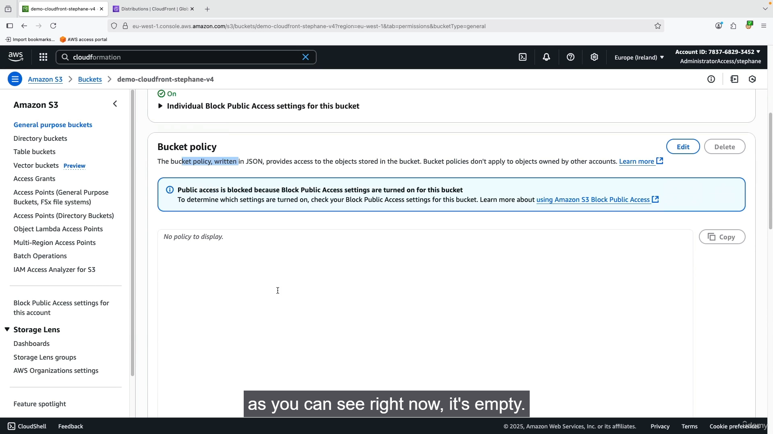

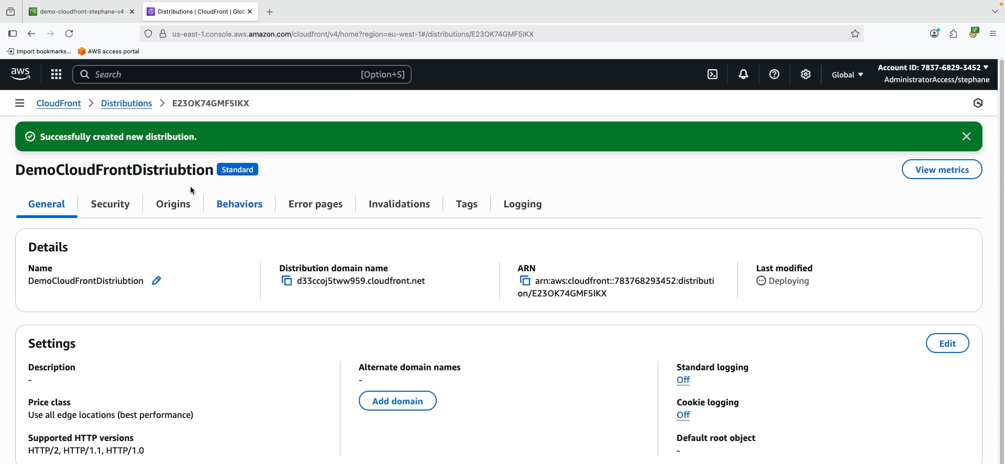

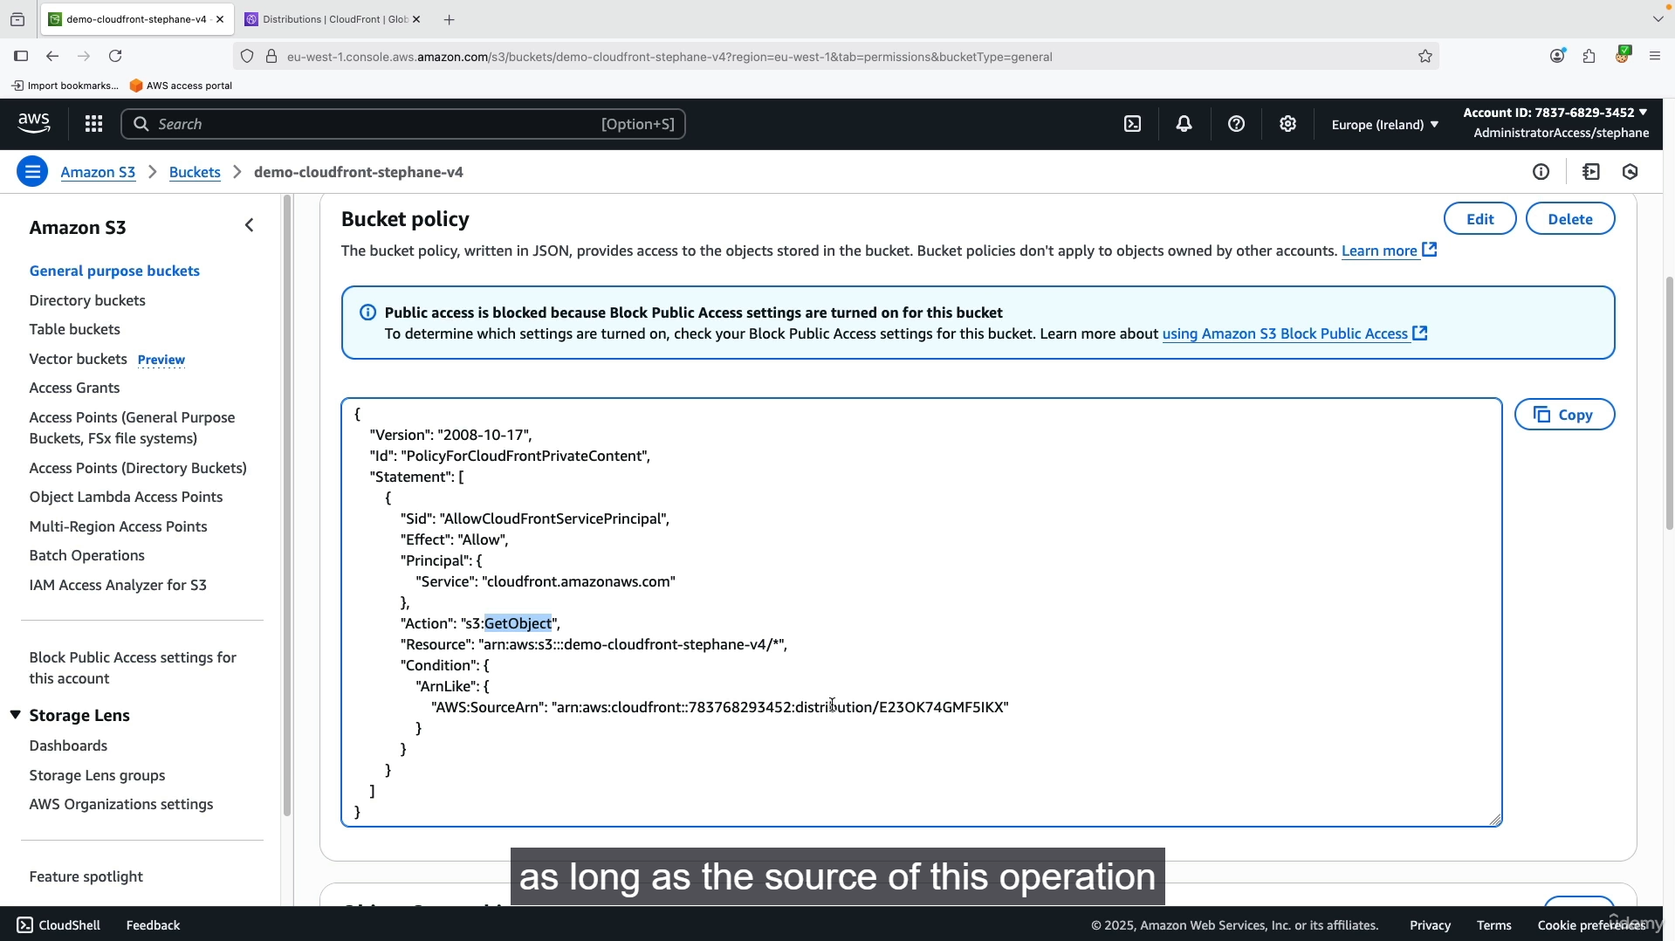

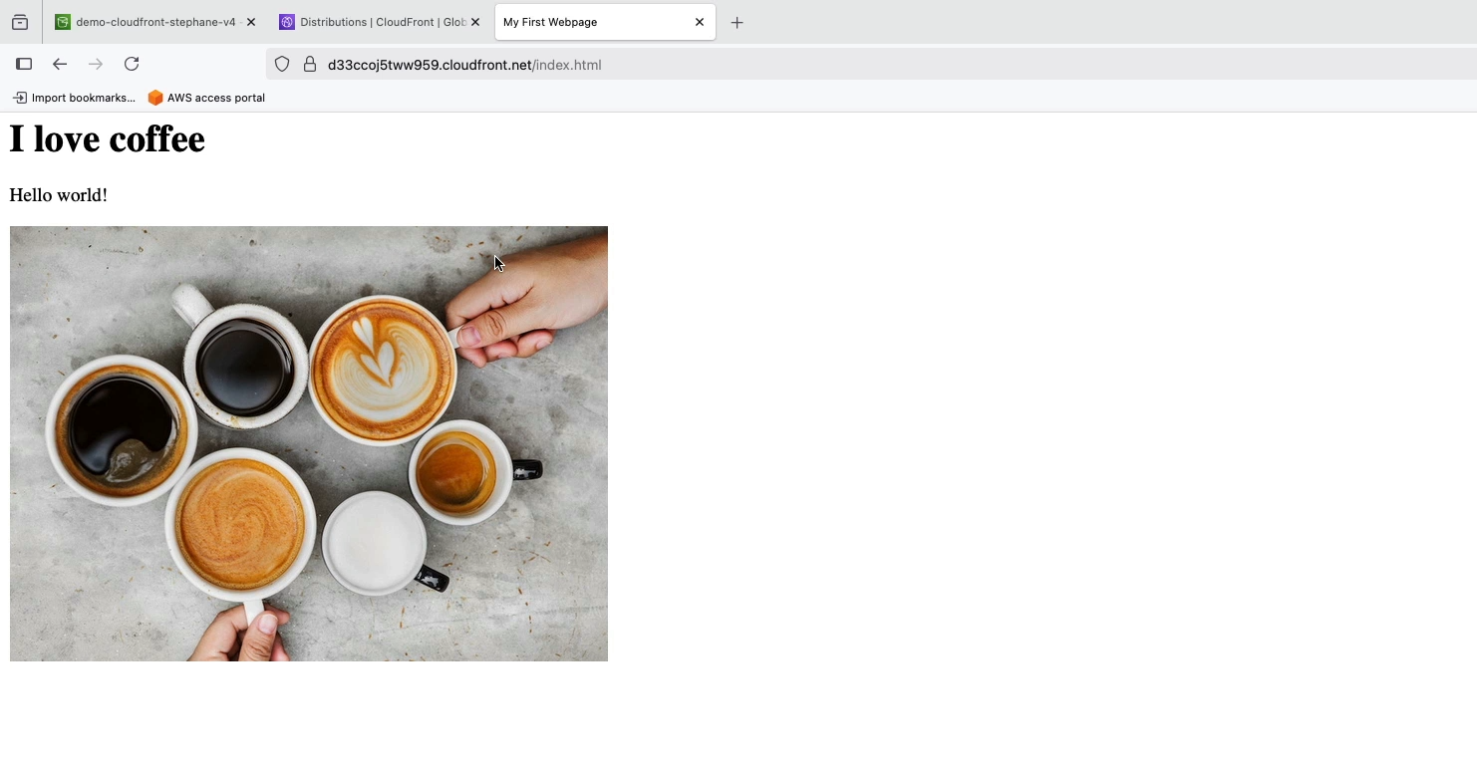

**1. Create a Private S3 Bucket and Upload Files**

1. Go to the **S3** console.
2. Click **"Create bucket"** and give it a globally unique name (e.g., demo-cloudfront-stephane-v4).
3. Leave all default settings. **Do not enable public access.**
4. Upload your files (beach.jpg, coffee.jpg, and index.html) to the bucket.
5. Verify that the objects are **private** by trying to access their Object URLs directly. This should result in an "Access Denied" error.

**2. Create a CloudFront Distribution**

1. Go to the **CloudFront** console.
2. Click **"Create distribution."**
3. Under "Origin," select your S3 bucket from the dropdown list.
4. Set **"S3 bucket access"** to **"Yes, use OAC (recommended)."** OAC stands for **Origin Access Control**. This feature allows CloudFront to privately access your S3 bucket without making its contents public to the internet.
5. CloudFront will prompt you to create a new OAC. Accept the recommended settings.
6. Under "Default cache behavior," leave the default settings.
7. Click **"Create distribution."**

**3. Verify the S3 Bucket Policy**

1. After the distribution is created, go back to your S3 bucket.
2. Navigate to the **"Permissions"** tab and click on **"Bucket policy."**
3. You will see that CloudFront has automatically added a policy. This policy explicitly allows the CloudFront service to perform s3:GetObject actions on your bucket's files, but only when the request originates from your specific CloudFront distribution. This ensures that the files remain private and can't be accessed directly via S3's public URL.

**4. Test the CloudFront Distribution**

1. Wait for the distribution status to change from "Deploying" to **"Enabled."** This can take a few minutes.
2. Once deployed, copy the **Distribution domain name** from the CloudFront console.
3. Paste the domain name into your browser's address bar and append the file names:
   * http://<your-distribution-domain>/index.html
   * http://<your-distribution-domain>/coffee.jpg
   * http://<your-distribution-domain>/beach.jpg
4. You will successfully see the web page and images. This confirms that CloudFront is serving the content from your private S3 bucket. 🌍

**5. Benefits of This Setup**

* **Enhanced Security:** Your S3 objects remain private. Users can only access them through the CloudFront distribution, not by bypassing it and using the raw S3 URL.
* **Improved Performance:** CloudFront caches your files at edge locations worldwide. The next time a user requests a file, it's served from the nearest edge location, which significantly reduces latency and improves load times.
  + 1. **S3 Transfer Acceleration:**

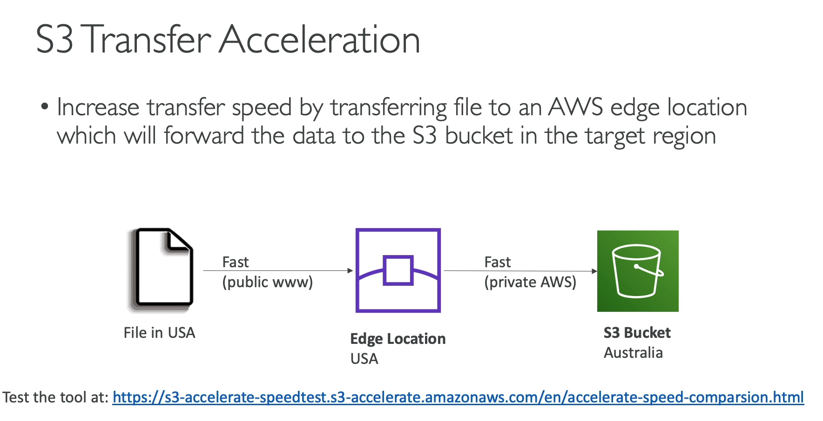

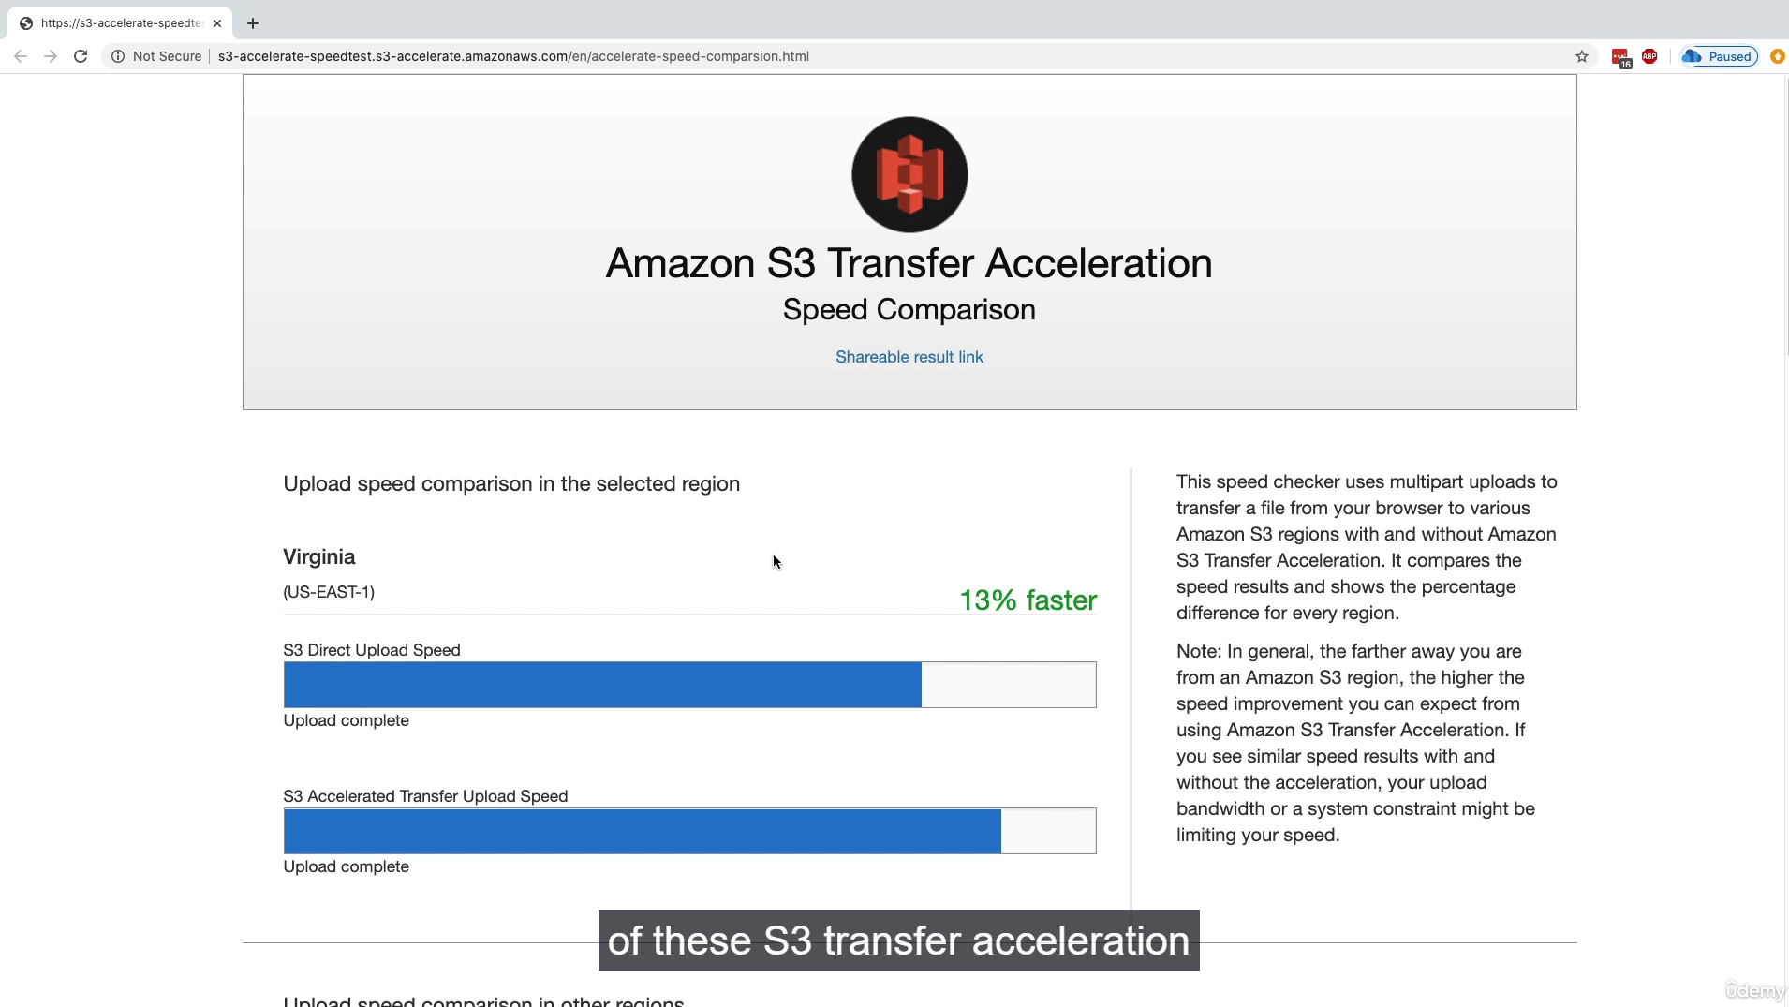

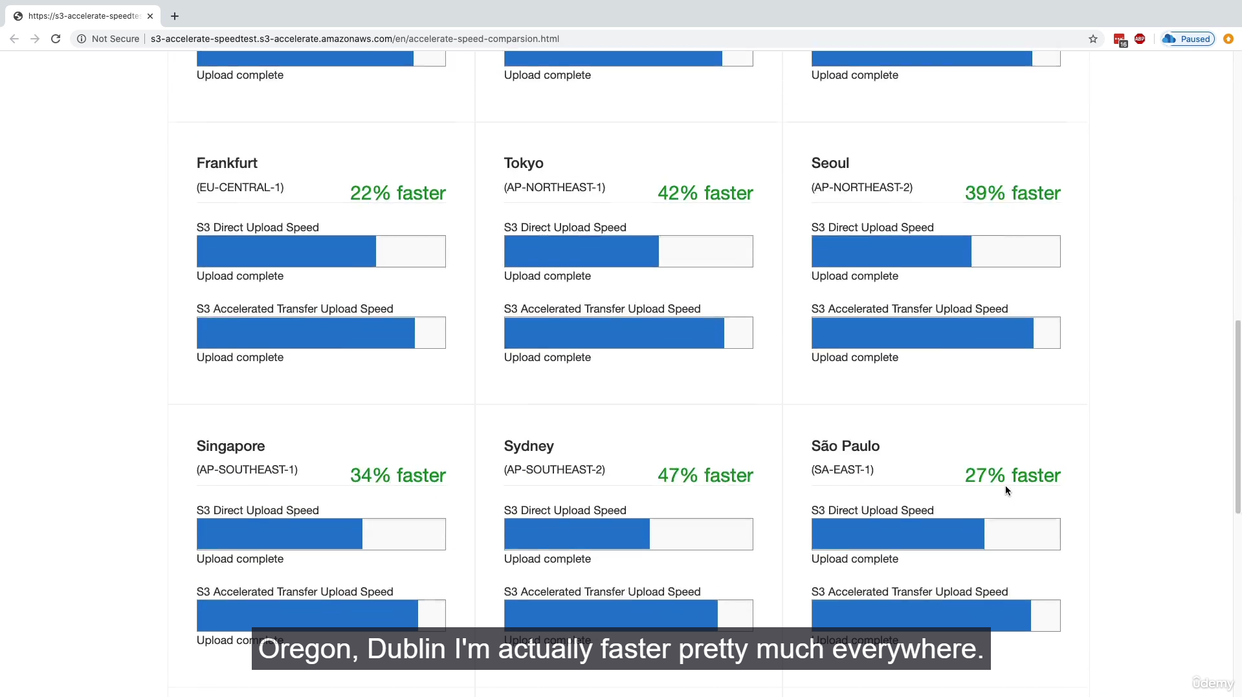

S3 Transfer Acceleration is a feature that speeds up file uploads and downloads to and from an Amazon S3 bucket. It is particularly effective when the user is geographically distant from the bucket's region.

**How it Works ⚙️**

S3 Transfer Acceleration leverages the global network of **AWS Edge Locations**. Instead of a user uploading a file directly to the S3 bucket in a distant region, the file is first uploaded to an Edge Location close to the user. This transfer occurs over the public internet, but for a very short distance. From the Edge Location, the file is then transferred to the destination S3 bucket over the **AWS private, high-speed network**. This internal network is optimized for fast and reliable data transfer, avoiding the congestion and unpredictable performance of the public internet over long distances.

**Key Points for Understanding 📝**

* **Problem Solved:** It addresses the latency issues that arise from long-distance data transfers over the public internet.
* **Mechanism:** The service uses **CloudFront's global network of Edge Locations** as a temporary staging point for data before it is routed to the destination S3 bucket.
* **Use Case:** It is ideal for applications with a global user base that needs to upload or download files to and from a single, centralized S3 bucket. For example, a photo-sharing application where users from all over the world upload pictures to a single S3 bucket in the US.
* **Performance:** The effectiveness of S3 Transfer Acceleration depends on the user's location, internet connection, and the distance to the S3 bucket. A practical test often shows significant speed gains, especially over long distances.
* **Enabling:** It is a bucket-level setting that can be enabled or disabled.
  + 1. **AWS Global Accelerator:**

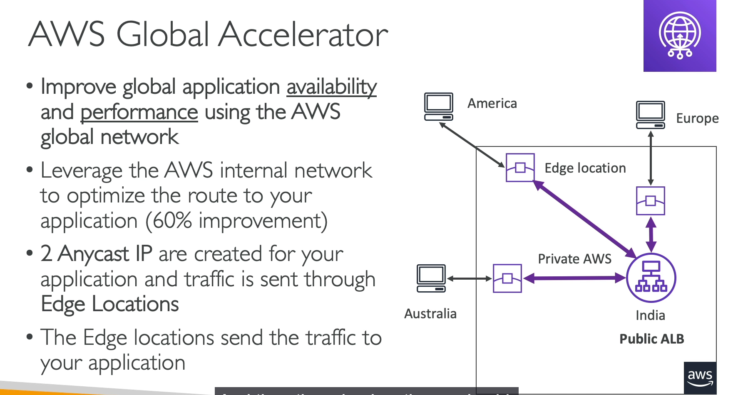

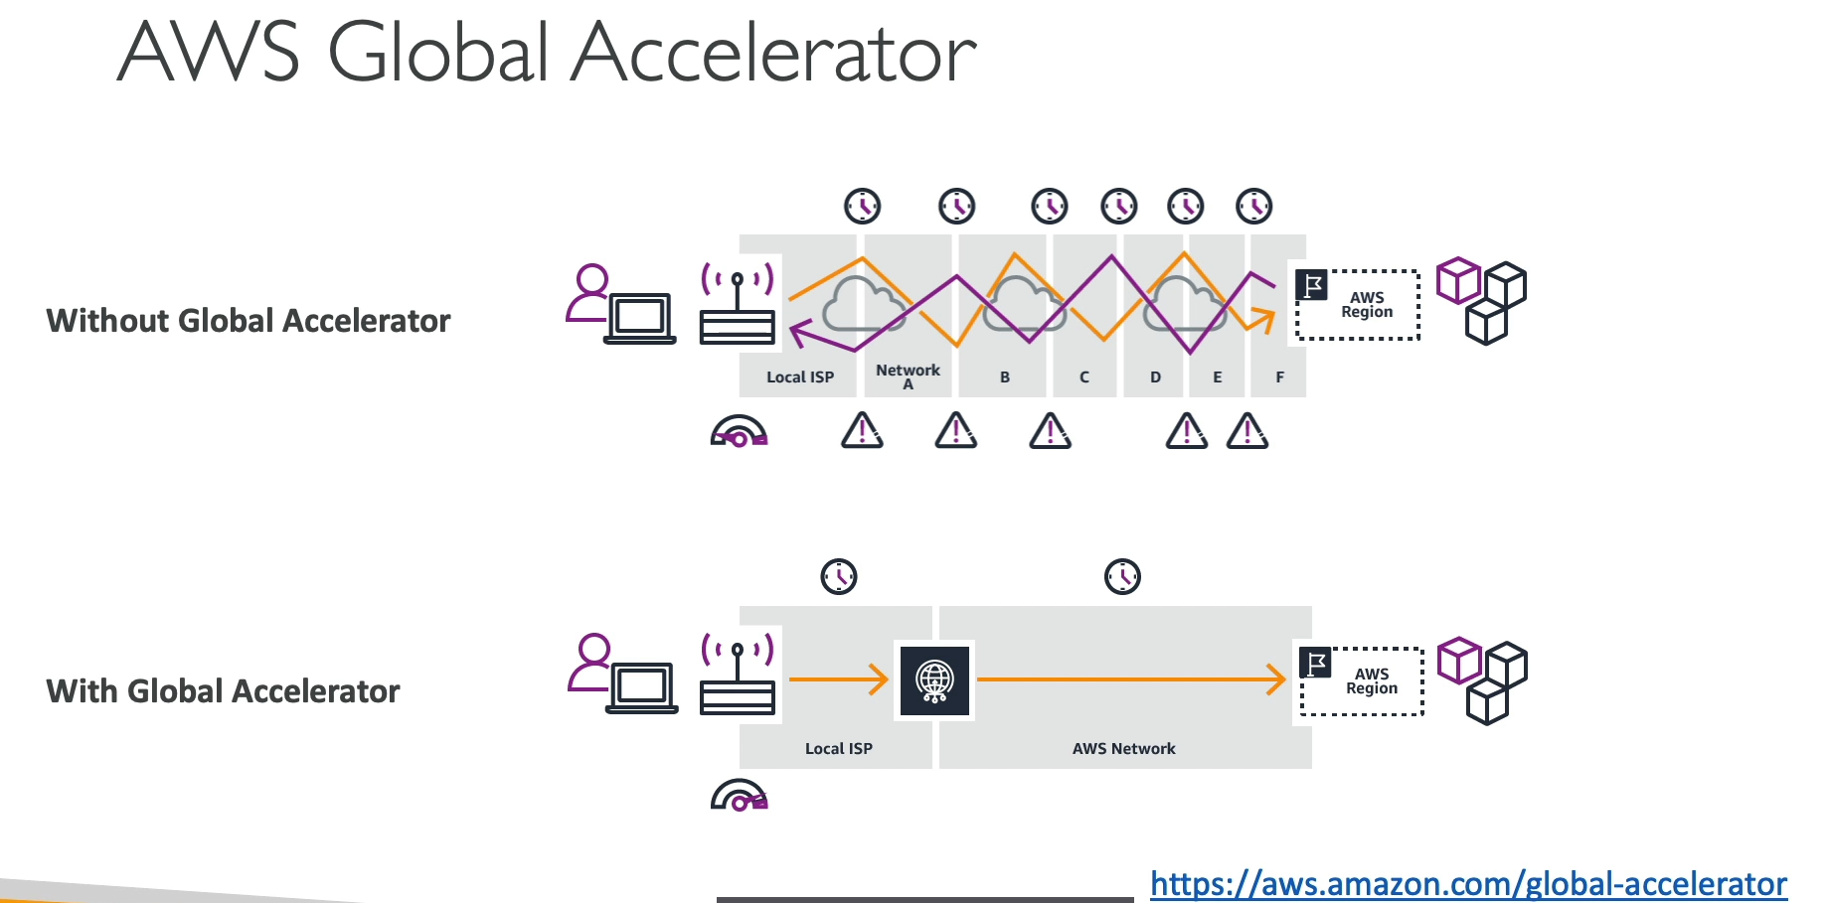

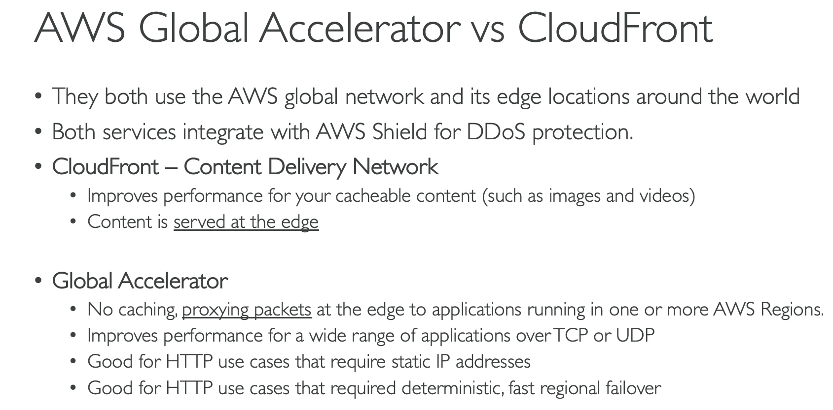

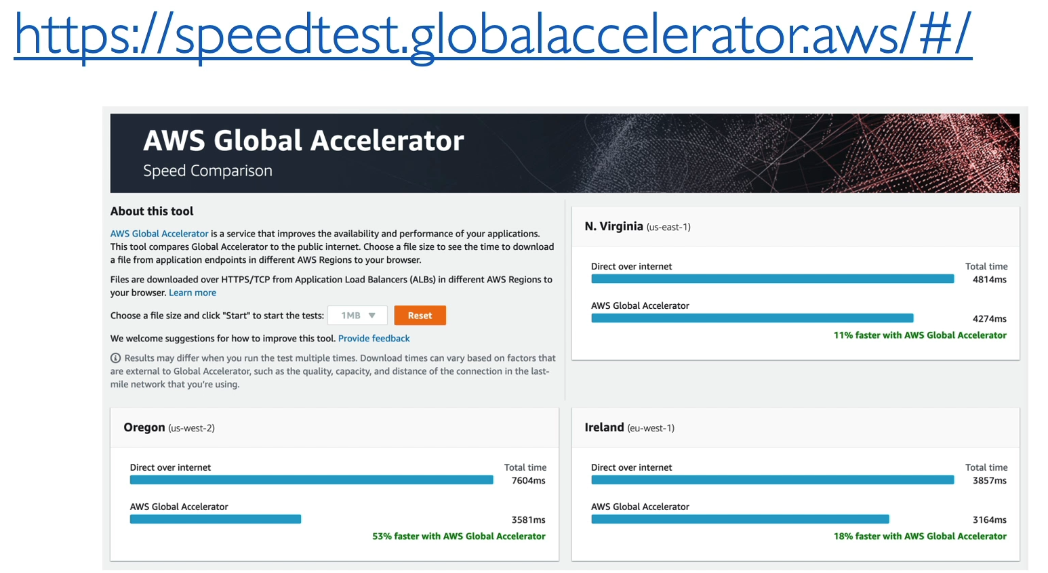

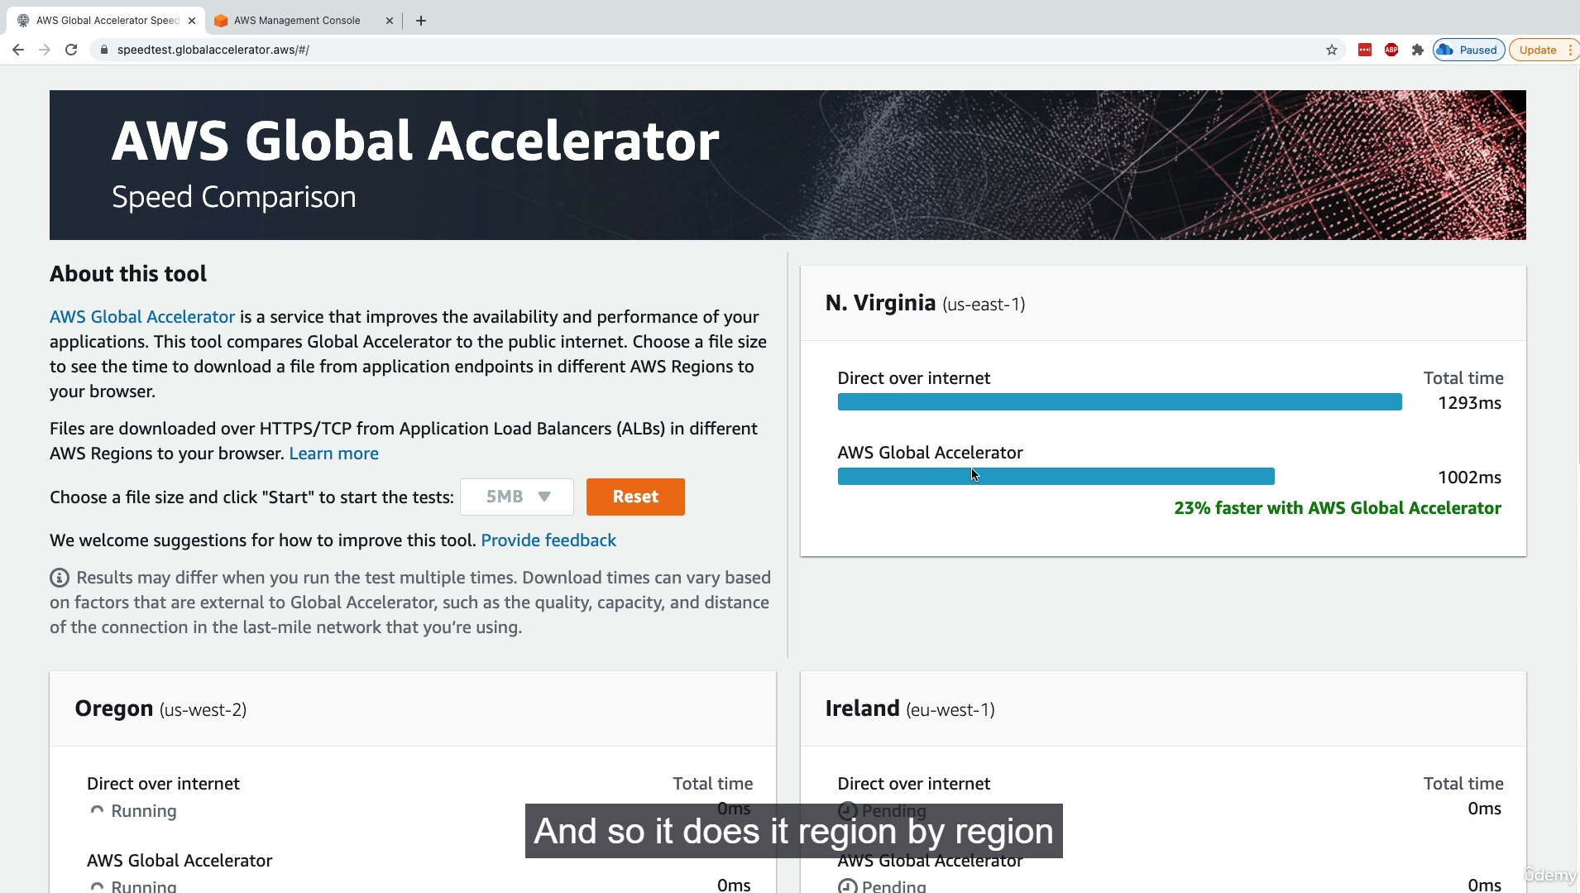

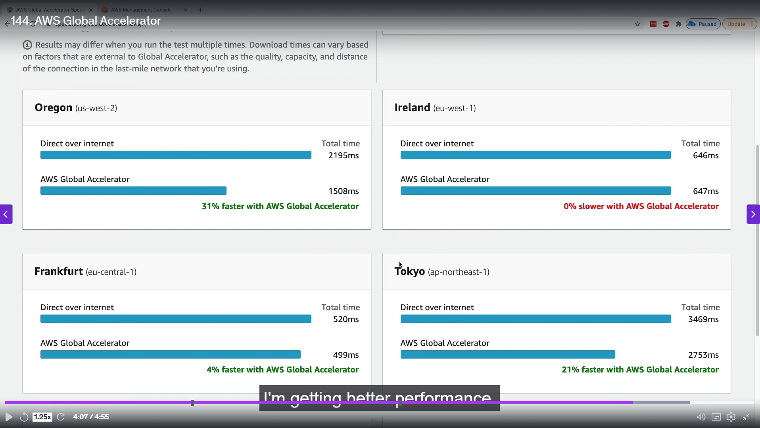

AWS Global Accelerator is a networking service that improves the availability and performance of your applications by directing user traffic through the AWS global network. It's designed to optimize the path from your users to your application endpoints, regardless of where they are in the world.

**How It Works ⚙️**

Global Accelerator provides **two static Anycast IP addresses** that act as a fixed entry point for your application. When a user connects to one of these IPs, their request is routed to the closest AWS Edge Location. From there, the traffic travels over the highly reliable and congestion-free **private AWS network** to your application's endpoint in an AWS region. This approach bypasses the unpredictable performance of the public internet over long distances.

**Key Features and Benefits 🚀**

* **Improved Performance:** By leveraging the AWS private network, Global Accelerator optimizes the route to your application, leading to faster response times and reduced latency for users globally.
* **Static IP Addresses:** The service provides two static Anycast IP addresses, which are a fixed point of entry for your application. This simplifies DNS configurations and is useful for applications that require a static IP.
* **Increased Availability:** Global Accelerator continuously monitors the health of your application endpoints and automatically routes traffic away from unhealthy ones. This provides fast, deterministic failover to another healthy endpoint, enhancing your application's availability.
* **Hybrid Service:** It can route traffic to endpoints within AWS (e.g., Application Load Balancers, EC2 instances) as well as to endpoints outside of AWS.
* **Protocol Support:** Unlike CloudFront, which primarily works with HTTP/HTTPS, Global Accelerator is designed for a wide range of applications and protocols, including **TCP and UDP**.

Global Accelerator vs. CloudFront:

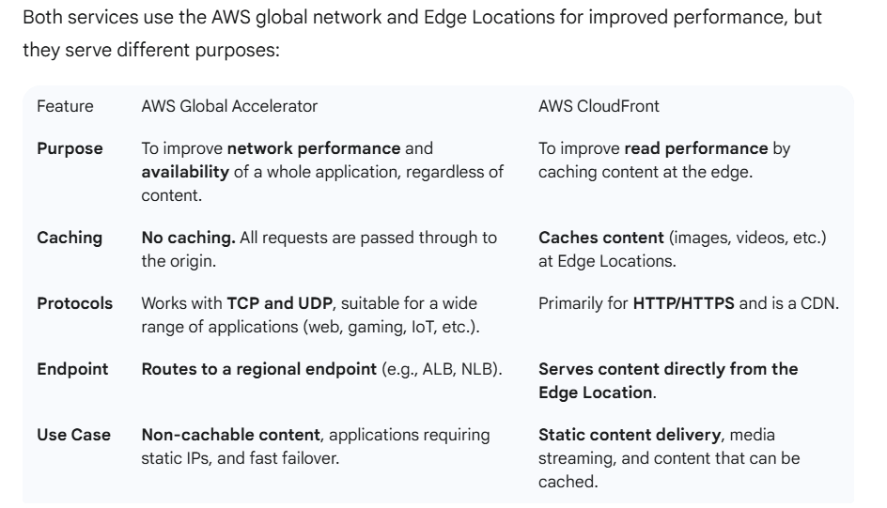

* + 1. **AWS Outposts:**

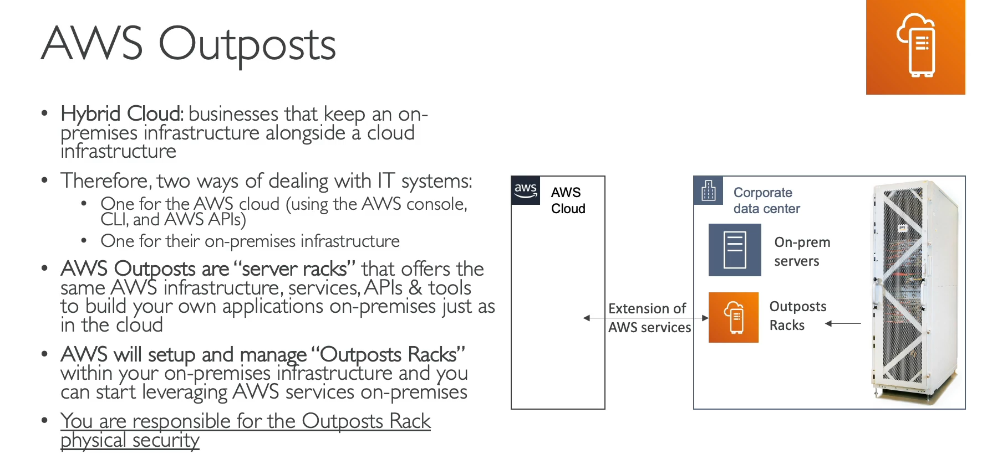

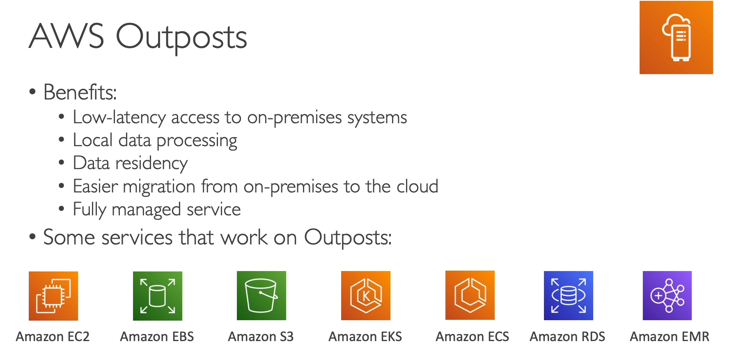

Hybrid cloud refers to an IT environment where an organization uses both its on-premises infrastructure and a public cloud infrastructure. This approach allows businesses to leverage the benefits of cloud computing while keeping some workloads and data on-site.

**AWS Outposts: Extending the Cloud On-Premises 🌐**

**AWS Outposts** are server racks built by AWS that are installed directly in your on-premises data center. They provide the same AWS infrastructure, hardware, APIs, and services you use in the cloud, allowing you to run AWS services locally.

**How It Works ⚙️**

AWS delivers and manages the Outposts racks, which are essentially a physical extension of an AWS Region. These racks are preloaded with select AWS services (like EC2, EBS, and S3). Your on-premises applications can then access these local AWS services with very low latency. While the hardware is on your premises, it is managed and updated by AWS.

**Key Benefits 🚀**

* **Low Latency:** Outposts are ideal for workloads that require very low latency access to on-premises systems, such as industrial automation, real-time analytics, and healthcare applications.
* **Data Residency:** It allows you to process and store data locally to meet regulatory or data residency requirements. The data does not have to leave your data center to be processed by AWS services.
* **Unified Experience:** You get a consistent experience using the same AWS APIs, tools, and services on-premises as you do in the cloud. This simplifies operations and reduces the need for different skill sets.
* **Seamless Cloud Migration:** Outposts can act as a stepping stone for migrating workloads from on-premises to the cloud. You can run applications on Outposts and then migrate them to a full AWS Region when ready.
* **Managed Service:** AWS handles the management, maintenance, and updates of the Outposts racks, freeing your IT team from this responsibility.

**Key Distinction 🛡️**

Although Outposts are a fully managed service, you are still responsible for the **physical security** of the racks and the on-premises environment where they are hosted.

* + 1. **AWS Wavelength:**

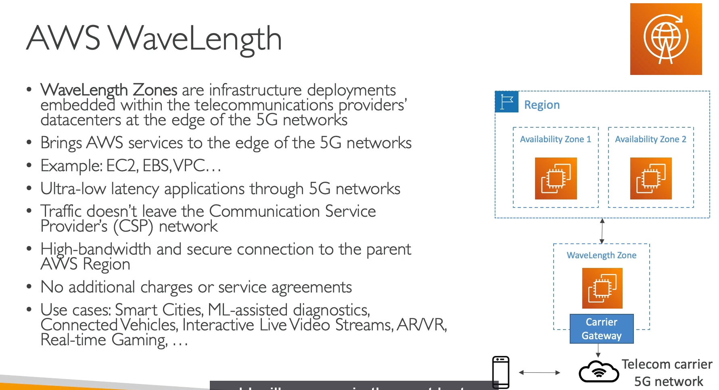

AWS Wavelength is an infrastructure offering that brings AWS compute and storage services to the edge of 5G networks. It's designed to provide ultra-low latency for applications that require real-time processing and communication with mobile devices.

**How It Works ⚙️**

Wavelength Zones are AWS infrastructure deployments embedded directly within a telecommunications provider's data centers. You can extend a VPC from a parent AWS Region to a Wavelength Zone and deploy specific AWS resources like EC2 instances and EBS volumes within it. This places your application physically close to 5G users, allowing traffic to be routed directly from the mobile device to the application without leaving the carrier's network. This bypasses the public internet, dramatically reducing latency to single-digit milliseconds. The Wavelength Zone is still connected to the parent AWS Region, so applications can seamlessly access other regional AWS services like databases (RDS, DynamoDB).

**Key Benefits 🚀**

* **Ultra-Low Latency:** The primary benefit is achieving the lowest possible latency for applications serving mobile users on 5G networks.
* **Edge Computing:** It allows you to process data and run applications at the network edge, which is crucial for real-time services.
* **Seamless Integration:** Wavelength Zones are a logical extension of your VPC, allowing you to use familiar AWS services, APIs, and tools to manage your application.
* **Hybrid Connectivity:** While designed for 5G traffic, your Wavelength Zone can connect back to the parent AWS Region for access to other services.

**Use Cases 💡**

Wavelength is tailored for applications that rely on the speed and low latency of 5G. Common use cases include:

* **Real-time Gaming:** Providing responsive, lag-free gaming experiences.
* **Autonomous Vehicles:** Enabling real-time communication between vehicles and the cloud for advanced driver assistance and safety.
* **Live Video Streaming & AR/VR:** Delivering immersive, high-quality video and augmented reality experiences with minimal buffering.
* **Industrial Automation & Smart Cities:** Processing data from IoT sensors in real-time to enable immediate decision-making.
  + 1. **AWS Local Zones:**

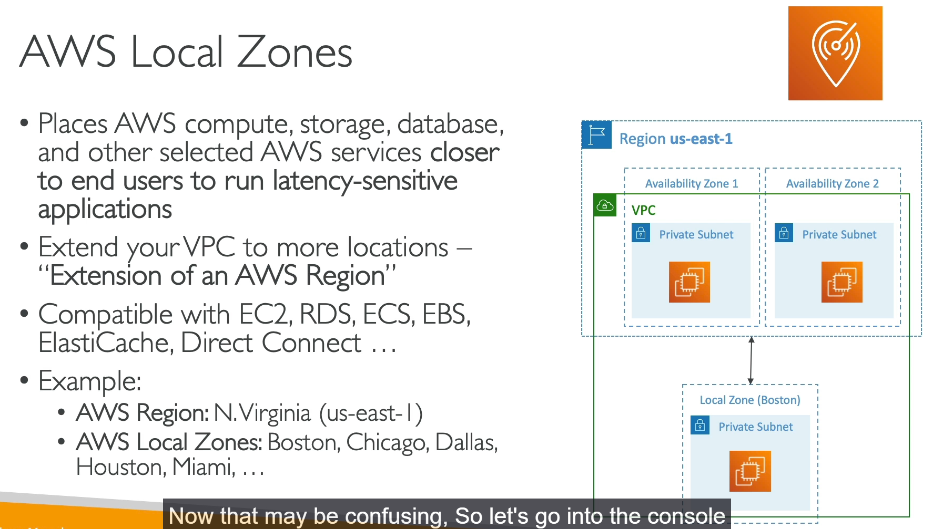

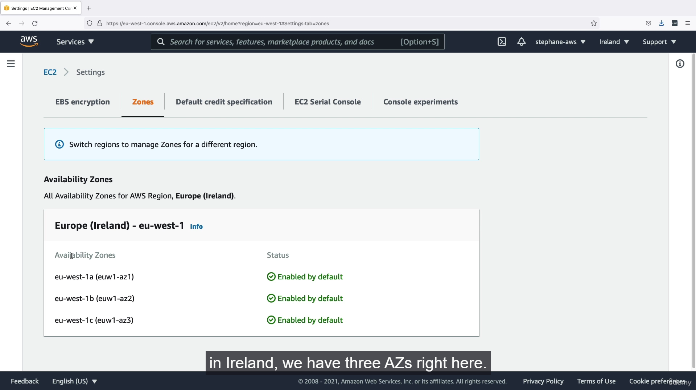

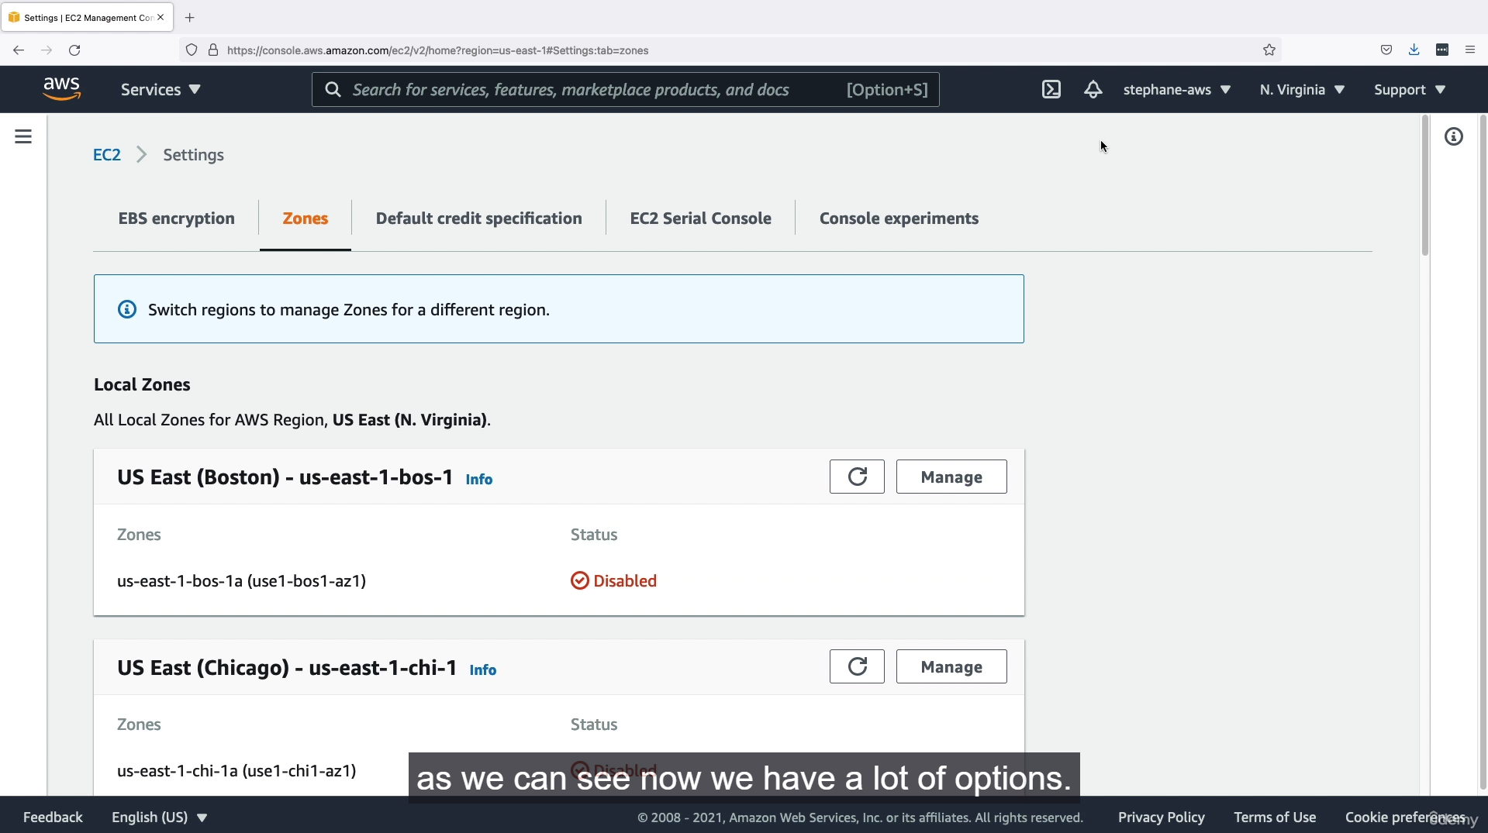

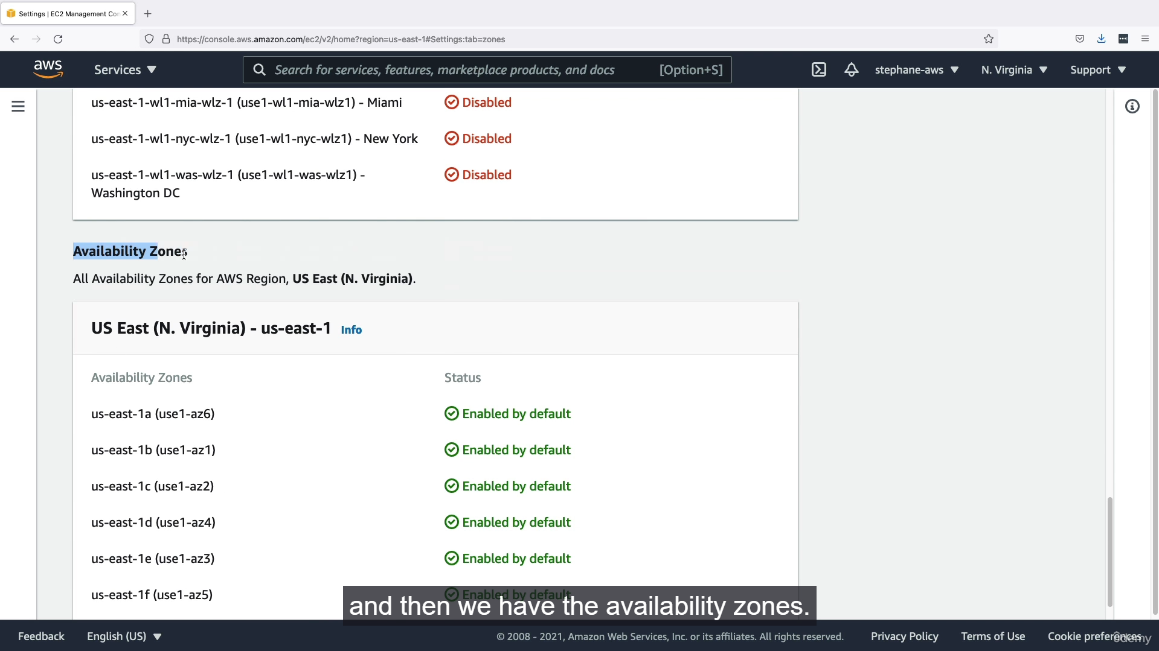

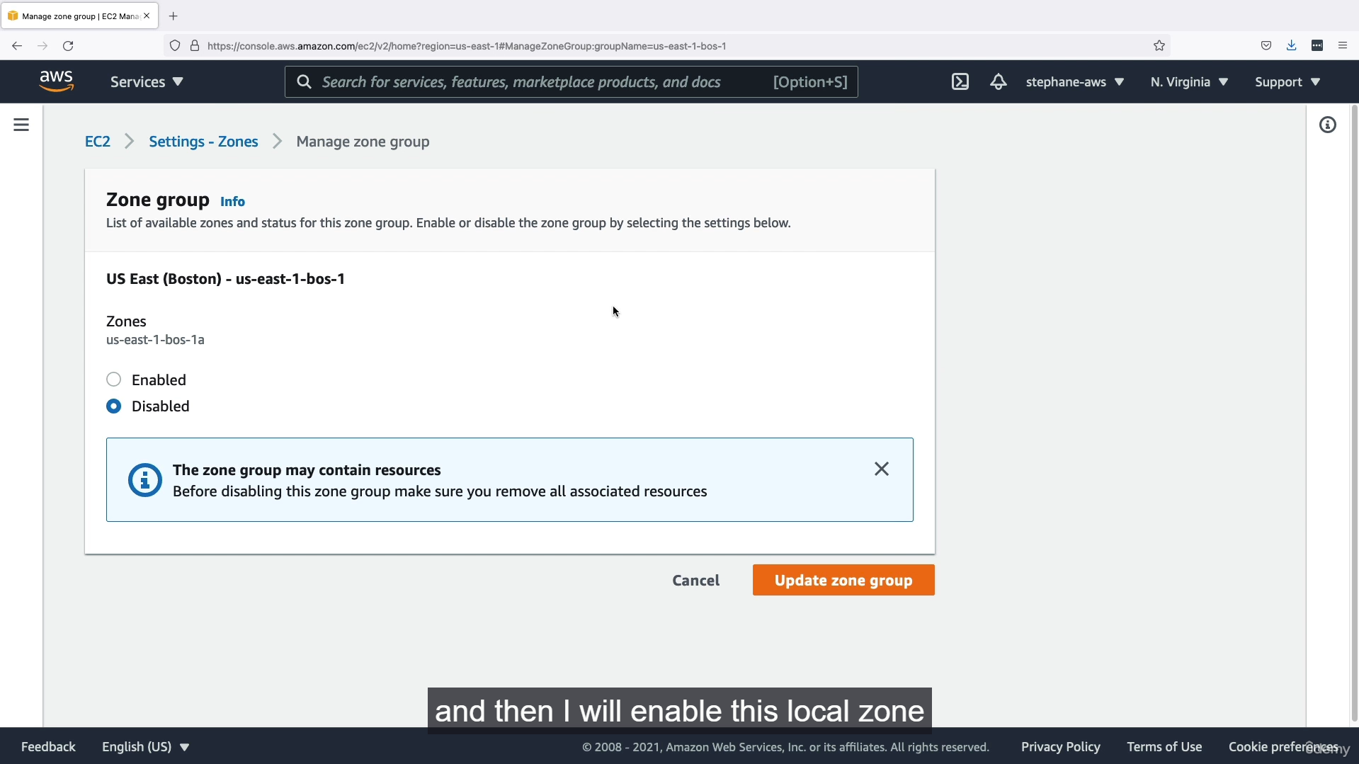

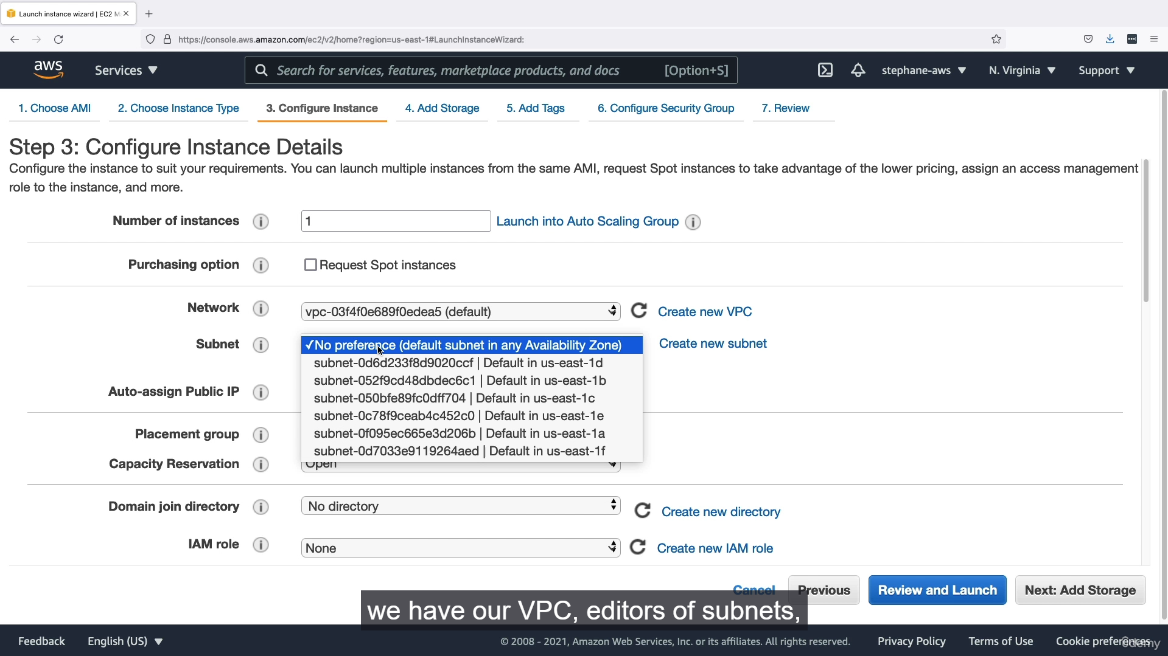

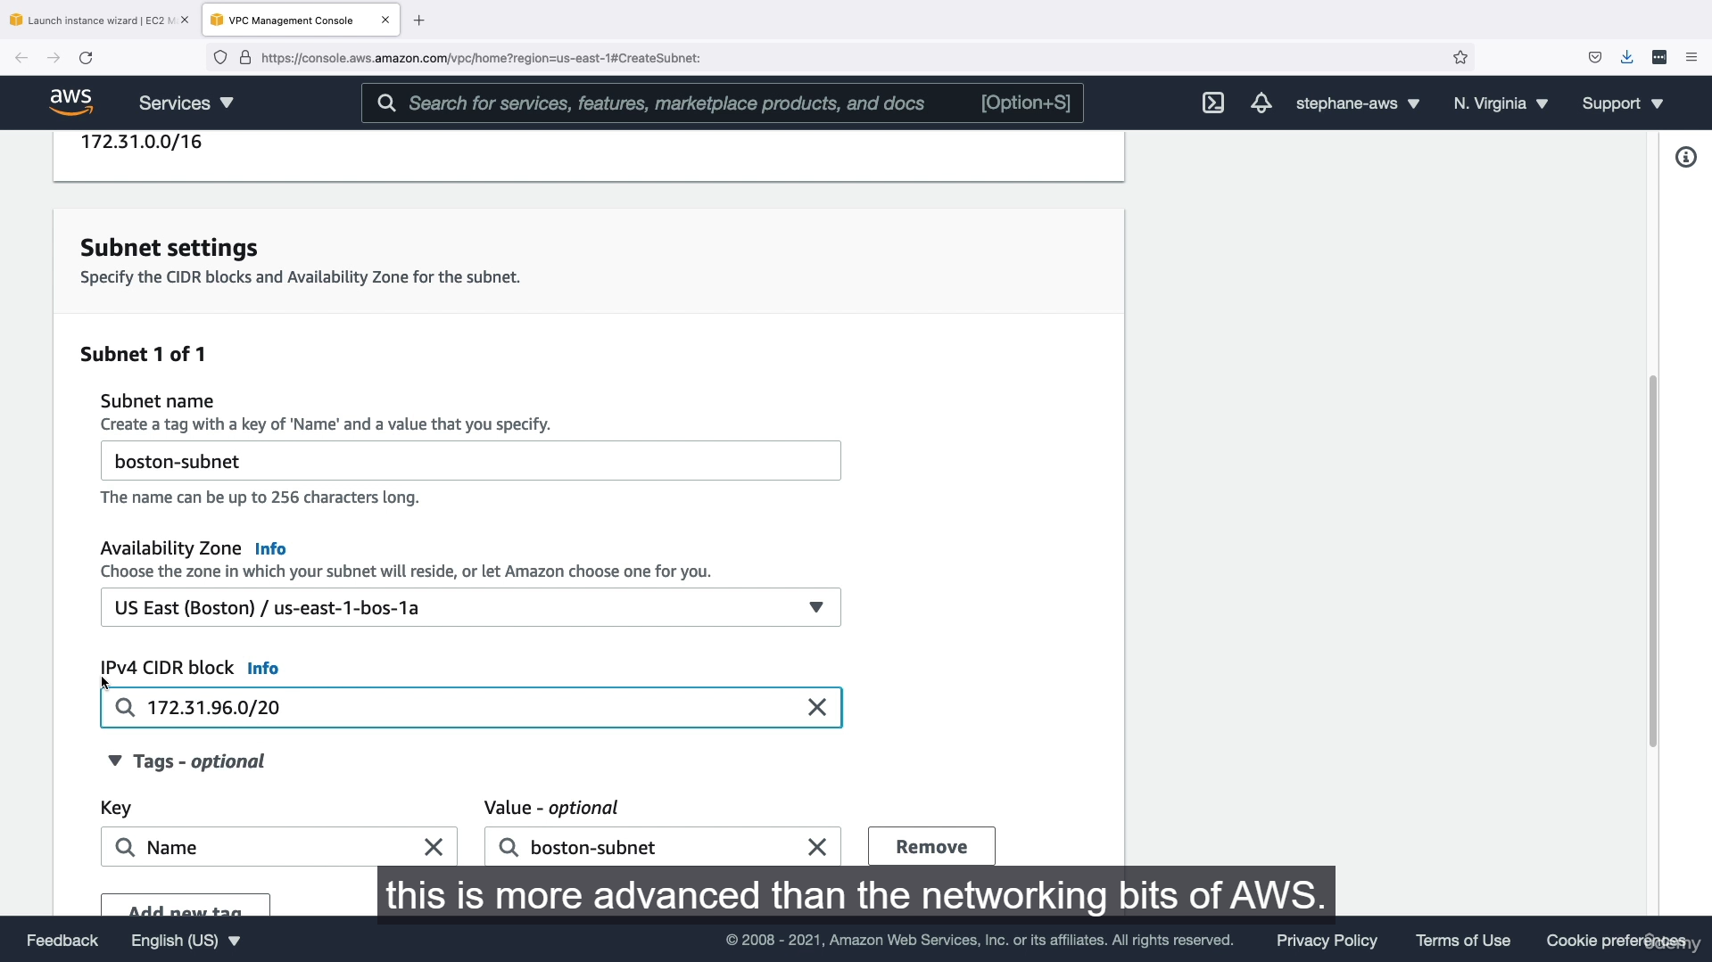

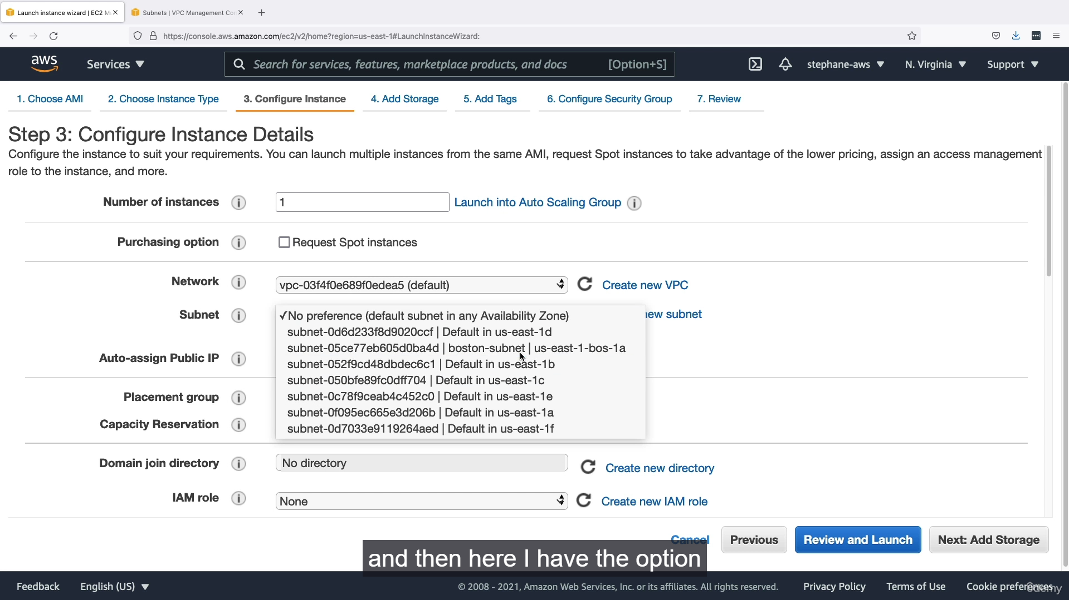

Local Zones are an AWS infrastructure offering that places select compute, storage, database, and other services closer to end users in major population, industry, and IT centers. They are an extension of an AWS Region, allowing you to deploy latency-sensitive applications with single-digit millisecond latency.

**How it works ⚙️**

You can extend your VPC from a parent AWS Region into a Local Zone. This allows you to create a new subnet within your VPC that is associated with the Local Zone. You can then launch AWS resources like EC2 instances into this new subnet, placing them closer to your users. All traffic within the Local Zone is routed to the parent AWS Region over the low-latency AWS network, giving you access to the full suite of AWS services while benefiting from local compute and storage.

**Key Points for understanding 💡**

* **Location:** Local Zones are in major metropolitan areas, enabling you to deliver applications that require extremely low latency for users in those specific geographies.
* **Logical Extension:** They are **not** standalone regions. They are a logical extension of a parent AWS Region, which means you manage them using the same APIs, tools, and console you use for the parent region.
* **Services Supported:** You can deploy a select set of services within a Local Zone, including EC2, EBS, ECS, ElastiCache, and others. For services not available in the Local Zone, you would use the fast, private connection to the parent region.
* **Low Latency:** The primary benefit is to serve applications that require single-digit millisecond latency, such as real-time gaming, media and entertainment content creation, and live streaming.
* **VPC Extension:** To use a Local Zone, you must first enable it and then create a new subnet within your VPC that's tied to that specific Local Zone.

**Local Zones vs. Wavelength Zones 🤝**

While both are "edge computing" solutions, their target use cases differ.

* **Local Zones:** Designed for **low-latency applications serving a local user base over wired networks**. For example, a gaming server in Boston serving gamers in the northeastern U.S.
* **Wavelength Zones:** Specifically designed for **ultra-low latency applications serving mobile users on 5G networks**. They are embedded within a telecom carrier's data center to minimize latency for mobile devices.
  + 1. **Global Applications Architecture:**

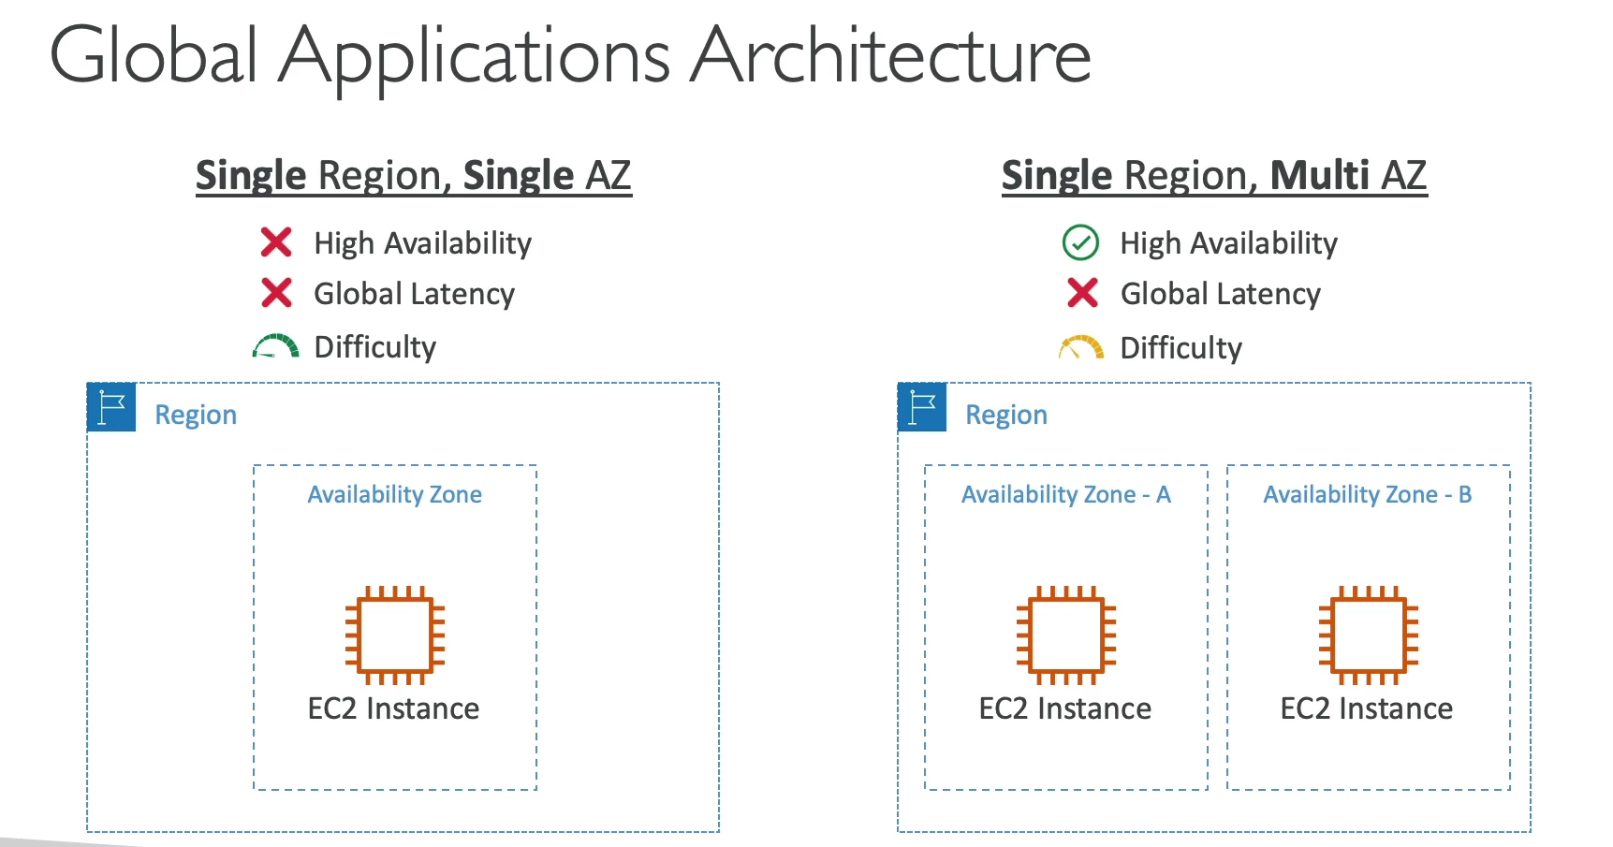

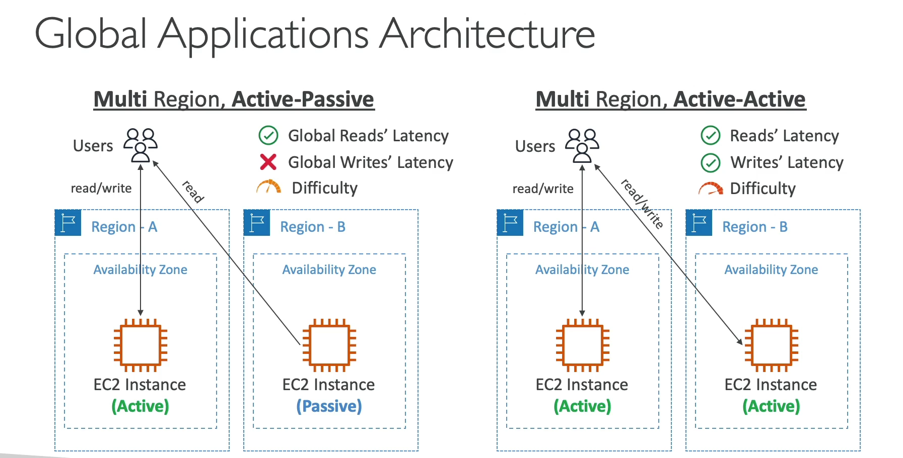

Architecting a global application on AWS involves choosing the right deployment strategy to balance high availability, low latency, and operational complexity. These strategies range from a single point of failure to a fully resilient global presence.

**Single Region, Single AZ**

This is the simplest architecture. An application (e.g., an EC2 instance) is deployed in a single Availability Zone (AZ) within one AWS Region.

* **High Availability:** None. If the AZ fails, the application goes down.
* **Latency:** High for users far from the region.
* **Difficulty:** Very low.

**Single Region, Multi-AZ**

The application is deployed across multiple AZs within a single region. This is a common and highly recommended approach for regional high availability.

* **High Availability:** Yes. If one AZ fails, the application remains available in the other(s).
* **Latency:** High for global users, as all AZs are within the same region.
* **Difficulty:** Low to medium.

**Multi-Region: Active-Passive**

In this disaster recovery strategy, the application is deployed in at least two regions. One region is **active** and handles all read and write traffic. The other region(s) are **passive** and receive data replication from the active region. Users cannot write to the passive regions. If the active region fails, traffic is manually or automatically failed over to one of the passive regions.

* **High Availability:** Yes, provides disaster recovery against a regional outage.
* **Latency:**
  + **Reads:** Improved, as users can be directed to the passive region closest to them for read-only access.
  + **Writes:** Still high for global users, as all writes must go to the single active region.
* **Difficulty:** High.

**Multi-Region: Active-Active**

In this most complex and robust strategy, the application is deployed in multiple regions, and **each region is capable of handling both reads and writes**. Data is replicated between all active regions.

* **High Availability:** Very high. It's resilient to an entire region failure and provides the best possible performance.
* **Latency:**
  + **Reads & Writes:** Both read and write latency are significantly reduced for global users, as they can be routed to the closest active region for all operations.
* **Difficulty:** Very high. This requires a sophisticated application design, often leveraging services like **DynamoDB Global Tables** or **Aurora Global Database**, to handle data replication and consistency issues.
  + 1. **Summary:**



